E-LEARNING PURCHASES

Project Overview and Objective
- This project is focused on the design and implementation of a relational database for an e-learning data’s.
- The project contains 3 tables such as Leaners ,Courses,Purchase tables.
- It can be used to manage the e-purchasing transaction records.
- The analysis perform the records to perform the sales and learners’ preference and priorities.

Data Sources :
The data are manually inserted for the month of Jan-2022 to Dec-2022

Problem Statement
- The goal is to develop the MySQL solution script that perform the interaction with relational database management systems (RDBMS).
- The users perform retrieving the specific information from the database.
- It supports the major commands like Create, Inserting, Select, where, Group By Clauses, Joins and aggregate functions.
- The analysis performs the total revenues by category order, high priorities for the course purchased online.

Attribute (Column/Features) Details
The project contains 1 database name : E_learning_pur_db., Contains 3 table are :-
E_learning_pur_db..

tbl_Course tbl_Lerners tbl_Purchase
1 Table: tbl_Lerners:
Attribute Name | Data Type | Description
lerner_id | Integer | Unique identifier for the lerners Id,Primary key ,auto increment for the lerner
full_name | Varchar | Lerners Name
Country | Varchar | Lerners country (Place)who purchased the course

2.Table: tbl_Course
Attribute Name | Data Type | Description
course_id | Integer | Unique identification for the course, Primary key for the course
course_name | Varchar | Course Name
Category | Integer | Department belongs to the Course
unit_price | Decimal | Cost of the course

3.Table: tbl_Purchase
Attribute Name | Data Type | Description
Purchase_ID | Integer | Unique identification for course purchase
course_id | Integer | Unique identification for the course
lerner_id | Integer | Unique identification for the learners
quantity | Integer | No.of course purchased by the individuals(learner)
purchase_date | Date | course purchased date

Tools & Technologies
● MYSQL:
Creating database and schema, Perform data exporations.

Key Insights :-
- Total Revenue finding for the course
Query:-
Select L.full_name as” Lerner Name”, C.course_name “Course Name”,C.category,P.quantity,C.unit_price,(C.unit_price*P.quantity) as Total_Revenue, P.purchase_date from tbl_Course C
join tbl_purchase P on P.course_id=C.course_id
join tbl_lerners L on L.lerner_id=P.lerner_id
order by P.purchase_date desc;
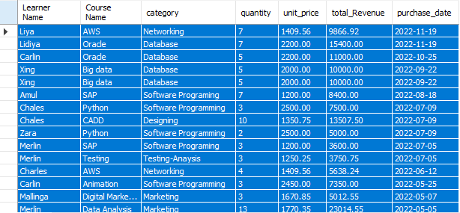

▪ Couries Purchased more course:-
select L.country,count(P.quantity) as "Total_Course Purchased By Country",sum(P.quantity*C.unit_price) as " Country Total Revenue"
from tbl_Course C
join tbl_purchase P on P.course_id=C.course_id
join tbl_lerners L on L.lerner_id=P.lerner_id
Group by L.country
order by sum(P.quantity*C.unit_price) Desc,count(P.quantity) ;

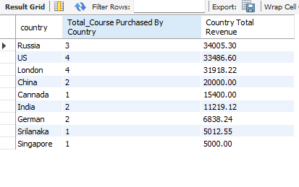
▪ Total Revenue: Total revenue generated from Jan-2022 to Dec-2022 is 162880.03.
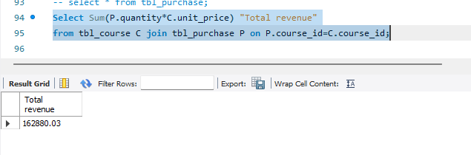

▪ Total Revenue for Each Course:-
select C.course_name, C.category,sum(C.unit_price*P.quantity) as "Total Revenue", count( distinct L.lerner_id) as " Unique Lerner"
from tbl_course C inner join tbl_Purchase P on P.course_id=C.course_id
inner join tbl_Lerners L on L.lerner_id=P.lerner_id
Group by C.category, L.lerner_id,C.course_name
Order by count( distinct L.lerner_id) Asc, sum(C.unit_price*P.quantity) desc;

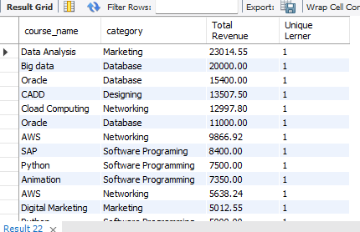

▪ Top 3 most Course Purchased:- The top most 3 course purchased and Total Sum of quantity is,
select C.course_name, sum(P.quantity) as " total quantity"
from tbl_course C
join tbl_purchase P on P.course_id=C.course_id
group by C.course_name,P.quantity
order by sum(P.quantity) desc
limit 3;
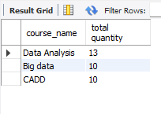

▪ learners who have purchased courses from more than one category: The learners who purchased more than 1categories.
select L.full_name as "Learner Name",L.country ,count(distinct C.category) as "Category"
from tbl_Lerners L
join tbl_purchase P on P.lerner_id=L.lerner_id
join tbl_Course C on C.course_id=P.course_id
group by L.full_name,L.country
Having count(distinct C.category)>1;

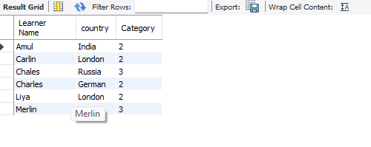
Not purchased Courses: The learner is not purchased courses currently.
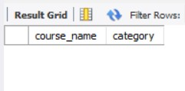

Conclusions :

- This analysis will perform to identify the most courses are purchased by the learners for the year of Jan-2022 to Dec-2022.
- Finding the total revenue earned by the course for the year of 2022.
- Finding the most top countries are involving to purchase course by the learners.
- Also Analysis the most prioritized the category by the leaners by the year of 2022.

A small percentage of learners are purchasing from multiple categories, suggesting an opportunity for cross-selling. b
▪ Focus marketing efforts on the "Top 3" courses identified to maximize ROI.
▪ Consider discounting or re-evaluating courses that are selling low.

